Exercise 1: Inventory Management System

1.1 Why data structures and algorithms are essential in handling large inventories?
= In inventory management system, a warehouse may store thousands of products.Efficient DSA helps in fast access of products, correct updation of informations, maintaining the scalability.

Types of data structures suitable for this problem
= LinkedList, TreeMap, HashMap, ArrayList etc.

1.2 Setup : a project named Inventory Management System

1.3 Implementation

import java.util.HashMap;
import java.util.Scanner;

class Product {
private int productId;
private String productName;
private int quantity;
private double price;

public Product(int productId, String productName, int quantity, double price) {
this.productId = productId;
this.productName = productName;
this.quantity = quantity;
this.price = price;
}

public int getProductId(){
return productId;
}

public String getProductName(){
return productName;
}

public int getQuantity(){
return quantity;
}

public double getPrice(){
return price;
}

public void setQuantity(int quantity){
this.quantity = quantity;
}

public void setPrice(double price){
this.price = price;
}

@Override
public String toString() {
return "ID: " + productId + ", Name: " + productName + ", Quantity: " + quantity + ", Price: " + price;
}
}

class Inventory {
private HashMap<Integer, Product> products;

public Inventory() {
products = new HashMap<>();
}

public void addProduct(Product product){
products.put(product.getProductId(), product);
System.out.println("Product added successfully");
}

public void updateProduct(int id, int quantity, double price){
Product p = products.get(id);

if (p != null){
p.setQuantity(quantity);
p.setPrice(price);
System.out.println("Product Updated");
}
else{
System.out.println("Product not found");
}
}

public void deleteProduct(int id){
if(products.remove(id) != null){
System.out.println("Product Deleted");
}
else{
System.out.println("Product Not Found");
}
}

public void displayInventory(){
for(Product p : products.values()){
System.out.println(p);
}
}
}

public class Main{
public static void main(String[] args){
Scanner sc = new Scanner(System.in);
Inventory inventory = new Inventory();

int choice;
do{
System.out.println("\n===== Inventory Management System =====");
System.out.println("1. Add Product");
System.out.println("2. Update Product");
System.out.println("3. Delete Product");
System.out.println("4. Display Inventory");
System.out.println("5. Exit");
System.out.println("Enter your choice: ");

choice = sc.nextInt();

switch (choice){
case 1:
System.out.println("Enter Product ID: ");
int id = sc.nextInt();
sc.nextLine();

System.out.println("Enter Product Name: ");
String name = sc.nextLine();

System.out.println("Enter Quantity: ");
int quantity = sc.nextInt();

System.out.println("Enter Price: ");
double price = sc.nextDouble();

Product product = new Product(id, name, quantity, price);
inventory.addProduct(product);
break;

case 2:
System.out.println("Enter Product ID to update: ");
int updateId = sc.nextInt();

System.out.println("Enter new quantity: ");
int newQuantity = sc.nextInt();

System.out.println("Enter new price: ");
double newPrice = sc.nextDouble();

inventory.updateProduct(updateId, newQuantity, newPrice);
break;

case 3:
System.out.println("Enter product ID to delete: ");
int deleteId = sc.nextInt();

inventory.deleteProduct(deleteId);
break;

case 4:
System.out.println("\nCurrent Inventory: ");
inventory.displayInventory();
break;

case 5:
System.out.println("Exiting program...");
break;

default:
System.out.println("Invalid choice!");
}
}while (choice != 5);

sc.close();
}
}
OUTPUT:

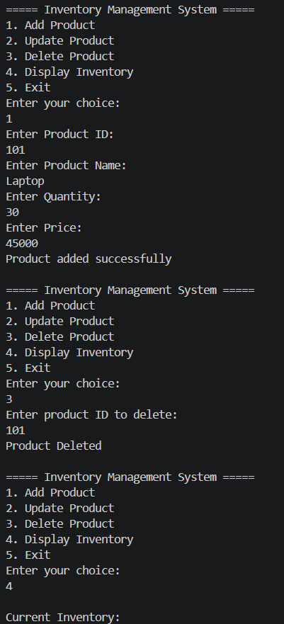

1.4 Time complexity for each operation (add, update, delete) would be O(1).
For the worst case scenario, it would be O(n).

Optimization techniques:
- Using HashMap instead of ArrayLIst will make the process faster.
- If we use Product ID as key, it will give direct access without searching.
- For very large warehouses, database can be used.

Exercise 2: E-commerce Platform Search Function

2.1 Big O notation measures how the running time of an algorithm grows as the input size increases.
Example: Assume there are n number of products.
If searching 100 products takes 100 comparisons and 1000 products takes 1000 comparisons then the time complexity will be O(n). [This is linear search.]

For search operation the best case scenario is O(1). The worst and average case scenarios are both O(n).

2.2 Setup and Implementation

LINEAR SEARCH

import java.util.Scanner;

class Product{
int productId;
String productName;
String category;

Product(int productId, String productName, String category){
this.productId = productId;
this.productName = productName;
this.category = category;
}

@Override
public String toString(){
return "ID: " + productId + ", Name: " + productName + ", Category: " + category;
}
}

public class LinearSearch {

public static Product linearSearch(Product[] products, int targetId){
for(int i = 0; i< products.length; i++){
if(products[i].productId == targetId){
return products[i];
}
}
return null;
}

public static void main(String[] args){

Scanner sc = new Scanner(System.in);

Product[] products = {
new Product(101, "Laptop", "Electronics"),
new Product(102, "Shirt", "Clothing"),
new Product(103, "Book", "Stationery"),
new Product(104, "Phone", "Electronics"),
new Product(105, "Shoes", "Footwear")
};

System.out.println("Enter Product ID to search: ");
int targetId = sc.nextInt();

Product result = linearSearch(products, targetId);

if(result != null){
System.out.println("Product Found: ");
System.out.println(result);;
}
else {
System.out.println("Product Not Found");
}

sc.close();
}
}

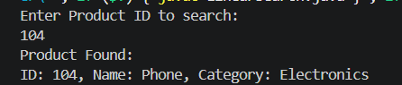

BINARY SEARCH

import java.util.Scanner;

class Product {
int productId;
String productName;
String category;

Product(int productId, String productName, String category) {
this.productId = productId;
this.productName = productName;
this.category = category;
}

@Override
public String toString() {
return "ID: " + productId + ", Name: " + productName + ", Category: " + category;
}
}

public class BinarySearch {
public static Product binarySearch(Product[] products, int targetId){
int low = 0;
int high = products.length -1;

while(low <= high){
int mid = (low + high) /2;

if(products[mid].productId == targetId){
return products[mid];
}

if(products[mid].productId < targetId){
low = mid + 1;
}
else{
high = mid -1;
}
}
return null;
}

public static void main(String[] args){

Scanner sc = new Scanner(System.in);

Product[] products = {
new Product(101, "Laptop", "Electronics"),
new Product(102, "Shirt", "Clothing"),
new Product(103, "Book", "Stationery"),
new Product(104, "Phone", "Electronics"),
new Product(105, "Shoes", "Footwear")
};

System.out.println("Enter Product ID to Search: ");
int targetId = sc.nextInt();

Product result = binarySearch(products, targetId);

if(result != null){
System.out.println("Product Found: ");
System.out.println(result);
}
else{
System.out.println("Product Not Found");
}

sc.close();
}
}

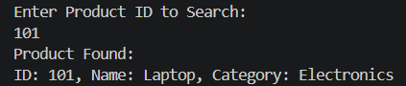

2.4 Analysis

The best, worst and average case scenarios for linear search are respectively O(1), O(n), O(n).
The best, worst and average case scenarios for binary search are respectively O(1), O(log n), O(log n).

According to me for this E-commerce platform Binary search is more suitable because
As E-commerce sites have thousands or millions of products, binary search reduces the search space by half of products. It is also much faster than linear search.

Exercise 3: Sorting Customer Orders

3.1 Different kind of sorting techniques

Bubble Sort : It repeatedly compares adjacent elements and swaps them if they are in the wrong order.
Insertion Sort : It builds the sorted array one element at a time by inserting each element into its correct position.
Quick Sort : It uses the divide and conquer technique. It first selects a pivot element. Place smaller elements to the left. Place larger elements to the right. Recursively sort both the halves.
Merge Sort : It also uses the divide and conquer technique. Divide the array into two halves. Recursively sort each half. Merge the sorted halves.

3.2 Setup and Implementation

BUBBLE SORT

class Order{
int orderId;
String customerName;
double totalPrice;

Order(int orderid, String customerName, double totalPrice){
this.orderId = orderid;
this.customerName = customerName;
this.totalPrice = totalPrice;
}

@Override
public String toString(){
return "Order ID: " + orderId + ", Customer: " + customerName + ", Total Price: " + totalPrice;
}
}

public class BubbleSort {

public static void bubbleSort(Order[] orders){
int n = orders.length;

for(int i = 0; i< n-1; i++){
for(int j = 0; j< n-i-1; j++){

if(orders[j].totalPrice > orders[j + 1].totalPrice){
Order temp = orders[j];
orders[j] = orders[j+1];
orders[j + 1] = temp;
}
}
}
}

public static void main(String[] args){
Order[] orders = {
new Order(1, "Alice", 250.0),
new Order(2, "Bob", 150.0),
new Order(3, "Charlie", 300.0),
new Order(4, "David", 200.0)
};

System.out.println("Before Sorting: ");

for(Order o : orders){
System.out.println(o);
}

bubbleSort(orders);

System.out.println("\nAfter Sorting: ");

for(Order o : orders){
System.out.println(o);
}
}
}

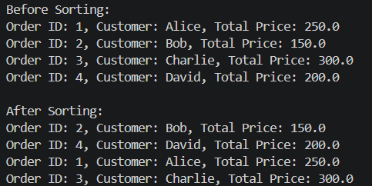
QUICK SORT

class Order{

int orderId;
String customerName;
double totalPrice;

Order(int orderId, String customerName, double totalPrice){
this.orderId = orderId;
this.customerName = customerName;
this.totalPrice = totalPrice;
}

@Override
public String toString(){
return "Order ID: " + orderId + ", Customer: " + customerName + ", Total Price: " + totalPrice;
}
}

public class QuickSort {
public static int partition(Order[] orders, int low, int high){
double pivot = orders[high].totalPrice;
int i = low -1;
for(int j= low; j< high; j++){
if(orders[j].totalPrice < pivot){
i++;
Order temp = orders[i];
orders[i] = orders[j];
orders[j] = temp;
}
}

Order temp = orders[i+1];
orders[i + 1] = orders[high];
orders[high] = temp;

return i+1;
}

public static void quickSort(Order[] orders, int low, int high){
if(low < high) {
int pivotIndex = partition(orders, low, high);

quickSort(orders, low, pivotIndex -1);
quickSort(orders, pivotIndex +1, high);
}
}

public static void main(String[] args){
Order[] orders = {
new Order(1, "Alice", 250.0),
new Order(2, "Bob", 150.0),
new Order(3, "Charlie", 300.0),
new Order(4, "David", 200.0)
};

System.out.println("Before Sorting: ");

for(Order o : orders){
System.out.println(o);
}

quickSort(orders, 0, orders.length-1);

System.out.println("\nAfter Sorting: ");

for(Order o: orders){
System.out.println(o);
}
}
}

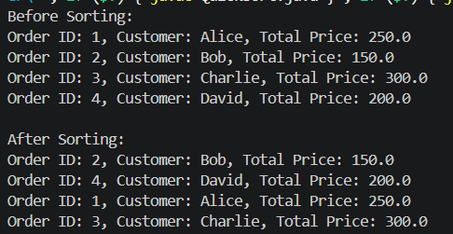
3.4 The time complexity for best case, worst case and average case scenario for bubble sort are respectively O(n), O(n^2), O(n^2).
The time complexity for best case, worst case and average case scenario for quick sort are respectively O(n log n), O(n^2), O(n log n).

Quick sort is generally preferred because its average-case time complexity is O(n log n), which is significantly better than Bubble sort which is O(n^2). Quick sort performs much better for large numbers of customer orders and it is more suitable for e-commerce platforms.

Exercise 4: Employment Management System

4.1 An array is a collection of elements stored in contiguous memory locations. Each element can be accessed using its index, which provides fast access to data. Arrays are simple to use, memory-efficient and allow direct access to implements in O(1) time.

4.2 Setup and Implementation

import java.util.Scanner;
class Employee{
int employeeId;
String name;
String position;
double salary;

Employee(int employeeId, String name, String position, double salary){
this.employeeId = employeeId;
this.name = name;
this.position = position;
this.salary = salary;
}

@Override
public String toString(){
return "ID: " + employeeId + ", Name: " + name + ", Position: " + position + ", Salary: " + salary;
}
}

public class EmployeeManagement {
static Employee[] employees = new Employee[100];
static int count = 0;

public static void addEmployee(Employee e) {
if(count < employees.length) {
employees[count] = e;
count++;
System.out.println("Employee added successfully");
}
}

public static void searchEmployee(int id){
for(int i = 0; i < count; i++){
if(employees[i].employeeId == id){
System.out.println("Employee Found: ");
System.out.println(employees[i]);
return;
}
}

System.out.println("Employee Not Found");
}

public static void traverseEmployee(){
if(count == 0){
System.out.println("No Employees to Display");
return;
}

for(int i = 0; i< count; i++){
System.out.println(employees[i]);
}
}

public static void deleteEmployee(int id){
int index =- 1;
for(int i = 0; i< count; i++){
if(employees[i].employeeId == id){
index = i;
break;
}
}
if(index == -1){
System.out.println("Employee Not Found");
return;
}

for(int i = index; i< count -1; i++){
employees[i] = employees[i + 1];
}

employees[count -1] = null;
count--;

System.out.println("Employee Deleted Successfully");
}

public static void main(String[] args) {

Scanner sc = new Scanner(System.in);

int choice;

do {

System.out.println("\n===== Employee Management System =====");
System.out.println("1. Add Employee");
System.out.println("2. Search Employee");
System.out.println("3. Display Employees");
System.out.println("4. Delete Employee");
System.out.println("5. Exit");

System.out.print("Enter Choice: ");
choice = sc.nextInt();

switch(choice) {

case 1:

System.out.print("Enter Employee ID: ");
int id = sc.nextInt();

sc.nextLine();

System.out.print("Enter Name: ");
String name = sc.nextLine();

System.out.print("Enter Position: ");
String position = sc.nextLine();

System.out.print("Enter Salary: ");
double salary = sc.nextDouble();

addEmployee(
new Employee(
id,
name,
position,
salary
)
);

break;

case 2:

System.out.print("Enter Employee ID: ");
id = sc.nextInt();

searchEmployee(id);

break;

case 3:

traverseEmployee();

break;

case 4:

System.out.print("Enter Employee ID: ");
id = sc.nextInt();

deleteEmployee(id);

break;

case 5:

System.out.println("Program Ended");
break;

default:

System.out.println("Invalid Choice");
}

} while(choice != 5);

sc.close();
}
}
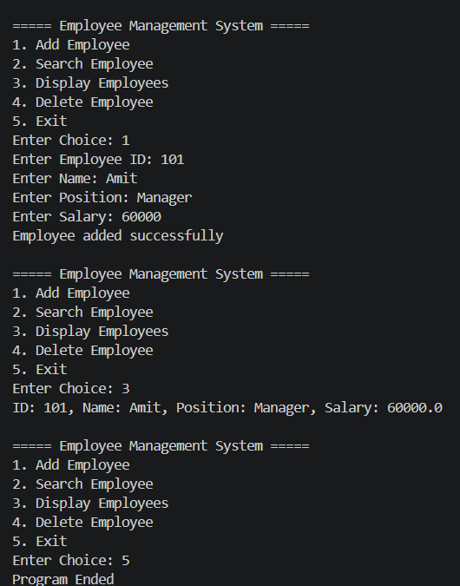

4.4 Analysis
Time complexity of
- Add Employee is O(1).
- Search Employee is O(n).
- Traverse Employee is O(n).
- Delete Employee is O(n).

Array has fixed size and cannot grow dynamically. Insertion and deletion operations are costly because elements may need to be shifted. When the number of records is not known in advance, arrays are not suitable.

Exercise 5 : Task Management System

5.1 A linked list is a dynamic data structure where elements are stored in nodes connected through links.
In a singly linked list, each node contains data and a reference to the next node.
In a doubly linked list, each node contains data , a reference to the next node and a reference to the previous node.
It allows efficient insertion and deletion of elements without shifting data.

5.2 Setup and Implementation

import java.util.Scanner;

class Task{
int taskId;
String taskName;
String status;

Task(int taskId, String taskName, String status){
this.taskId = taskId;
this.taskName = taskName;
this.status = status;
}
}

class Node{
Task task;
Node next;

Node(Task task){
this.task = task;
this.next = null;
}
}

public class taskManagement {
Node head = null;

public void addTask(Task task){
Node newNode = new Node(task);

if(head == null){
head = newNode;
}
else{
Node temp = head;

while(temp.next != null){
temp = temp.next;
}

temp.next = newNode;
}

System.out.println("Task added");
}

public void searchTask(int id){
Node temp = head;

while(temp != null){
if(temp.task.taskId == id){
System.out.println("Task Found: ");
System.out.println("ID: " + temp.task.taskId + ", Name: " + temp.task.taskName + ", Status: " + temp.task.status);
return;
}
temp = temp.next;
}
System.out.println("Task not found");
}

public void displayTasks() {

Node temp = head;

if(temp == null) {
System.out.println("No Tasks Available");
return;
}

while(temp != null) {

System.out.println(
"ID: " + temp.task.taskId +
", Name: " + temp.task.taskName +
", Status: " + temp.task.status
);

temp = temp.next;
}
}

public void deleteTask(int id) {

if(head == null) {
System.out.println("List Empty");
return;
}

if(head.task.taskId == id) {

head = head.next;
System.out.println("Task Deleted");
return;
}

Node temp = head;

while(temp.next != null &&
temp.next.task.taskId != id) {

temp = temp.next;
}

if(temp.next == null) {

System.out.println("Task Not Found");
return;
}

temp.next = temp.next.next;

System.out.println("Task Deleted");
}

public static void main(String[] args) {

Scanner sc = new Scanner(System.in);

taskManagement list =
new taskManagement();

int choice;

do {

System.out.println("\n===== Task Management System =====");
System.out.println("1. Add Task");
System.out.println("2. Search Task");
System.out.println("3. Display Tasks");
System.out.println("4. Delete Task");
System.out.println("5. Exit");

System.out.print("Enter Choice: ");
choice = sc.nextInt();

switch(choice) {

case 1:

System.out.print("Enter Task ID: ");
int id = sc.nextInt();

sc.nextLine();

System.out.print("Enter Task Name: ");
String name = sc.nextLine();

System.out.print("Enter Status: ");
String status = sc.nextLine();

list.addTask(
new Task(id, name, status)
);

break;

case 2:

System.out.print("Enter Task ID: ");
id = sc.nextInt();

list.searchTask(id);

break;

case 3:

list.displayTasks();

break;

case 4:

System.out.print("Enter Task ID: ");
id = sc.nextInt();

list.deleteTask(id);

break;

case 5:

System.out.println("Program Ended");
break;

default:

System.out.println("Invalid Choice");
}

} while(choice != 5);

sc.close();
}
}

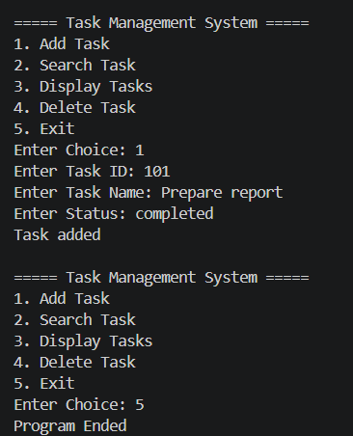

5.4 Analysis
Time complexity of
- Add Task is O(n).
- Search Task is O(n).
- Traverse Task is O(n).
- Delete Task is O(n).

Unlike arrays, linked lists do not require contiguous memory locations and do not need elements shifting during insertion and deletion. Therefore linked lists are more suitable for applications where data changes frequently.

Exercise 6: Library Management System

6.1 Linear Search checks each element one by one until the desired item is found. It can be used for both sorted and unsorted data.
Binary search repeatedly divides a sorted list into two halves and searches in the appropriate half, making it much faster for large sorted datasets.

6.2 Setup and Implementation
LINEAR SEARCH
import java.util.Scanner;

class Book{
int bookId;
String title;
String author;

Book(int bookId, String title, String author){
this.bookId = bookId;
this.title = title;
this.author = author;
}

@Override
public String toString(){
return "ID: " + bookId + ", Title: " + title + ", Author: " + author;
}
}

public class LinearSearchLibrary {
public static void linearSearch(Book[] books, String targetTitle){

for(int i = 0; i< books.length; i++){

if(books[i].title.equalsIgnoreCase(targetTitle)){
System.out.println("Book found: ");
System.out.println(books[i]);
return;
}
}

System.out.println("Book Not Found");
}

public static void main(String[] args){
Scanner sc = new Scanner(System.in);

Book[] books = {
new Book(1, "The Great Gatsby", "F. Scott Fitzgerald"),
new Book(2, "To Kill a Mockingbird", "Harper Lee"),
new Book(3, "1984", "George Orwell"),
new Book(4, "Pride and Prejudice", "Jane Austen"),
new Book(5, "The Catcher in the Rye", "J.D. Salinger")
};

System.out.println("Enter Book Title to Search: ");
String title = sc.nextLine();

linearSearch(books, title);
sc.close();
}
}

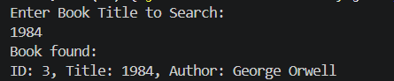

BINARY SEARCH

import java.util.Scanner;

class Book{
int bookId;
String title;
String author;

Book(int bookId, String title, String author){
this.bookId = bookId;
this.title = title;
this.author = author;
}

@Override
public String toString(){
return "Book ID: " + bookId + ", Title: " + title + ", Author: " + author;
}
}

public class BinarySearchLibrary {
public static void binarySearch(Book[] books, String targetTitle){
int low = 0;
int high = books.length - 1;

while(low <= high){
int mid = (low + high)/2;
int result = books[mid].title.compareToIgnoreCase(targetTitle);

if(result ==0){
System.out.println("Book Found: ");
System.out.println(books[mid]);
return;
}

else if(result < 0){
low = mid + 1;
}

else{
high = mid - 1;
}
}

System.out.println("Book Not Found");
}

public static void main(String[] args){
Scanner sc = new Scanner(System.in);

Book[] books = {
new Book(1, "The Great Gatsby", "F. Scott Fitzgerald"),
new Book(2, "To Kill a Mockingbird", "Harper Lee"),
new Book(3, "1984", "George Orwell"),
new Book(4, "Pride and Prejudice", "Jane Austen"),
new Book(5, "The Catcher in the Rye", "J.D. Salinger")
};

System.out.println("Enter Book Title: ");
String title = sc.nextLine();

binarySearch(books, title);

sc.close();
}
}

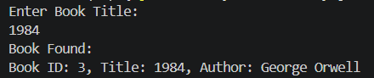

6.3 Analysis
The best, worst and average case scenarios for linear search are respectively O(1), O(n), O(n).
The best, worst and average case scenarios for binary search are respectively O(1), O(log n), O(log n).

Linear search is suitable for small or unsorted datasets because it does not require sorting.
Binary search is preferred for large datasets because it is much faster, but it can only be used when the data is sorted.
For a library system with many books, Binary search provides better performance and faster retrieval of records.

Exercise 7 : Financial Forecasting
7.1 Recursive is a programming technique in which a method calls itself to solve a problem. It breaks a complex problem into smaller subproblems until a base condition is reached. Recursion can simplify problems involving repeated calculations, such as financial forecasting, factorial computation, and tree traversal.

7.2 Setup
The future value can be predicted using formula :
Future Value = Present Value x (1 + Growth Rate)
Using recursion:
FV(n) = FV(n-1) x (1 + growthRate)
Base case:
FV(0) = Present value

7.3 Implementation

import java.util.Scanner;

public class FinancialForecast {
public static double forecast(double currentValue, double growthRate, int years){

if(years == 0){
return currentValue;
}

return forecast(currentValue, growthRate, years -1) * (1 + growthRate);
}

public static void main(String[] args){
Scanner sc = new Scanner(System.in);

System.out.println("Enter Present Value: ");
double presentValue = sc.nextDouble();

System.out.println("Enter Annual Growth Rate (%): ");
double rate = sc.nextDouble();

System.out.println("Enter Number of Years: ");
int years = sc.nextInt();

double futureValue = forecast(presentValue, rate / 100, years);

System.out.printf("Future Value after %d years = %.2f", years, futureValue);

sc.close();
}
}

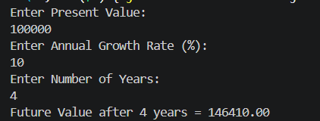

7.4 Analysis
For every recursive call, one year is processed.
Therefore Time complexity will be O(n)
N = number of years

The recursive solution can be optimised using an iterative approach to avoid excessive recursive calls and stack usage. An iterative solution uses constant memory and is mmore efficient for large values of n. Dynamic programming can also be used when repeated calculations occur.

